**Lab 2 Report**



Session: 2022 – 2026

**Submitted by:**

Robass Atif 2022-CS-150

**Submitted to:**

Sir Nauman Shafi

Department of Computer Science

**University of Engineering and Technology**

**Lahore Pakistan**

# Task 01:

* Create a file named “19f-XXXX.txt”. File must contain at least 10 lines.

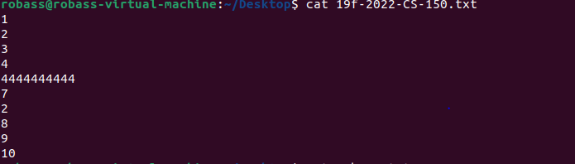

* Create another file named “your name.txt”. File must contain at least 10 lines.

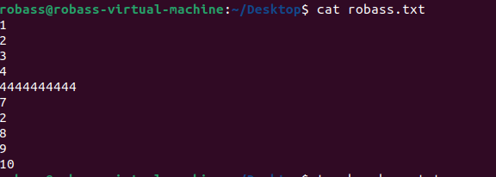

* . Merge the data of both files.



* Redirect the output to a new file.



* Display the first two lines of first file.



* Display the last two lines of second file.



* Finds the string (your roll#) from the first file.



* Grant the execute permission of the second file to the group.



* Remove the write permission for the owner.



* Now Mr. Tom suddenly lost the track of his current location. Help him find his location.



* He wants the list of all files present on Desktop directory



* Now he wanted to create a folder of his personal files and pictures named as your roll#



* Display the current time.



* He is done with the task and he is happy with your work. He want to display a thank you message.



# Task 02:

* Create a file named “19f-XXXX_OS-lab_rules.txt” using linux commands. The file must contain all lab rules covered in first lab.



* You want to set the rights of created file to this (- rwx r-x r--). For these rights, you are required to convert the given rights in numeric format using binary number system procedure covered in lecture. Show complete working.



* Now use the derived number to change the permission of a file using chmod command.



* Append the output of is command to created file.

